Unit 4 : Day 15 : Bridging the Gap Midterm Summative Assessment |  |  |  | Grade 11 U/C
Minds On: 10 |  | Description/Assessment Goals  - Students will solve a problem by creating a scale model, collecting data and creating an algebraic model  - Demonstrate an understanding of functions, and make connections between the numeric, graphical, and algebraic representations of quadratic functions (QFV.002)  - Solve problems involving quadratic functions, including those arising from real-world applications. (QFV.003) |  | Materials  - Grid chart paper  - Markers  - Thin chain (1m)  - BLM 4.15.1  - BLM 4.15.2  - BLM 4.15.3  - BLM 4.15.4  - TV VCR/DVD
Action: 60
Consolidate: 5
Total=75 min
Assessment
Opportunities
 | Minds On… | Whole Group → Discussion  Distribute BLM 4.15.1.  Activate prior knowledge on suspension bridges by leading a discussion on rope bridges like the Capillano suspension bridge in Vancouver BC or by showing pictures or video clips of suspension bridges from movies such as Indiana Jones: The Temple of Doom or Pirates of the Carribean: Dead Man’s Chest.  Distribute rubric (BLM 4.15.2). Discuss the criteria and qualifiers to clarify the expectations for the assessment. |  | www.capbridge.com  Note: a catenary is not a quadratic relation but approximates one. For more information see http://en.wikipedia.org/wiki/Catenary  Possible methods to determine algebraic models are: using the vertex form or factored form of the equation, or using the TRANSFRM app on the graphing calculator  Groups who were not successful in creating algebraic models can be provided with correct algebraic models.  Teacher notes and a solution are contained in BLM 4.15.4
 | Action! | Small Groups → Exploration  Distribute BLM 4.15.3  In homogenous groups of 3 or 4, students will create a scale model of the chasm on grid chart paper. After placing their model on a vertical surface, students will model the bridge using a thin chain to create a catenary. Students collect coordinates of several points including the low point and end points of the bridge. Students discuss the significance of the low point and the two end points. Students discuss possible ways to determine an algebraic model for this data.  Students will ensure that every group member has the data collected, graphical and algebraic models created.  Individual → Modelling  Students will create a graphical and two algebraic models of the data collected.
 | Consolidate Debrief | Whole Class → Collection of Materials  Students will submit their completed work into folders to be completed the next class. Teacher will evaluate student modelling and offer feedback for the next class using rubric (BLM 4.15.2)  Teachers can return the last page of BLM 4.15.3 the next class.
Research  Extra Practice |  | Home Activity or Further Classroom Consolidation  Have students research Bungee Jumping for the next class.  Students can review for pencil and paper test on expectations not assessed by this task.  Teacher can assign practice questions as required.
Midterm Summative Performance Task #1

4.15.1 Bridging the Gap
Extreme
Environment
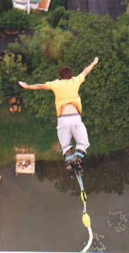

You are an engineer hired by a local nature adventure park Extreme Environment. The owners are considering a new attraction involving a bungee jump from a rope bridge over a span across the chasm. The bridge will be a suspension bridge. The bungee jump station will be located on the suspension bridge.

A surveyor measured the chasm and found:
- The chasm is 100 m wide
- At the bottom of the chasm is a river
- The river is 60 m below the edge of both sides of the chasm

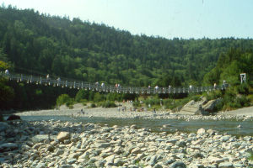
Local construction and safety codes state:
- The slope from the end of the bridge to a point on the bridge that is 5 m horizontally from the end of the bridge must be between 0.1 and 0.25.
- The bungee jump chord stretches to 90% of the vertical distance from the lowest point on the suspension bridge to the river.
- The bungee jump must be located at least 5 m away from the sides of the chasm.
- The minimum vertical distance a bungee jumper can come to the river is 10 m.

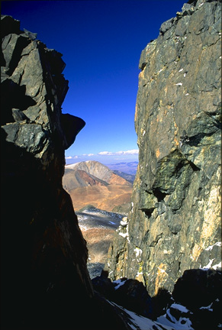

100m

4.15.1 Bridging the Gap (continued)

Your Task:

- Create a mathematical model for the bridge that is represented
  - numerically (table of values)
  - graphically
  - algebraically
- Analyze using your mathematical models:
  - Determine the minimum clearance from the bridge to the river below
  - Determine whether your model for the bridge meets the slope building code requirement.
  - Determine a range of horizontal distances where the bungee jump station could be located so it meets the safety requirements

The Plan:

Day 1:

Materials:
- Grid chart paper and markers
- Length of thin chain
- Masking Tape
- Pencils and ruler

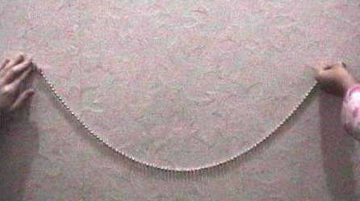
Method:
- Make a scale model of the chasm dimensions on grid chart paper.
- Model the suspension bridge using the thin chain.
- Collect co-ordinates of at least 5 points including the two end points and the low point of the bridge.
- Create a graphical model for your bridge on grid paper.
- Determine two algebraic models for your data.

Day 2:

Materials:
- Numerical and algebraic models from previous class
- Graphing calculator
- Pencils and ruler

Method:
- Discuss the strengths and weaknesses of your algebraic models.
- State the domain and range for each of your models
- Determine whether your bridge model meets the slope requirements in the building code requirement. How would you make adjustments to your model if you needed to?
- Determine the range of locations for the bungee jump station that meet the safety code requirements.
THINKING
Reasoning and Proving
Criteria |  | Level 1 |  | Level 2 |  | Level 3 | Level 4
Degree of clarity in explanations and justifications |  | Justifies in a way that is partially understandable |  | Justifies so that the teacher understands, but would likely be unclear to others |  | Justifies clearly for a range of audiences | Justifies particularly clearly and with detail
Making comparisons,  conclusions and justifications connected to the data |  | Justifies with a limited connection to the model presented |  | Justifies with some connection to the model presented |  | Justifies with a direct connection to the model presented | Justifies with a direct connection to the model presented, with evidence of reflection
Exploring and Reflecting
Reflecting on reasonableness of original hypothesis and revising if needed | Reflects and revises inappropriately to the  situations |  | Reflects and revises appropriately to include some situations |  | Reflects and revises appropriately to include most significant situations |  | Reflects and revises appropriately to include all situations
APPLICATION
Selecting Tools and Computational Strategies
Select and use appropriate tools and strategies to model the data, or solve a problem | Selects and applies with major errors, omissions, or mis-sequencing |  | Selects and applies with minor errors, omissions or mis-sequencing |  | Selects and applies accurately, and logically sequenced |  | Selects and applies accurately and logically sequenced, using the most appropriate tools
Connecting
Makes connections among graphical model and context |  | Makes limited connections |  | Makes some connections |  | Makes most connections | Makes all possible connections
Relate mathematical ideas to situations drawn from other contexts |  | Makes weak connections |  | Makes simple connections |  | Makes appropriate connections | Makes strong connections
COMMUNICATION
Representing
Creation of algebraic models to represent the data |  | Creates a model that represents little of the range of data |  | Creates a model that represents some of the range of data |  | Creates a model that represents most of the range of data | Creates a model that represents the full range of data
Communicating
Criteria |  | Level 1 |  | Level 2 |  | Level 3 | Level 4
Ability to read and interpret mathematical language, charts, and graphs |  | Misinterprets a major part of the information, but carries on to make some otherwise reasonable statements |  | Misinterprets part of the information, but carries on to make some otherwise reasonable statements |  | Correctly interprets the information, and makes reasonable statements | Correctly interprets the information, and makes subtle or insightful statements
Correct use of mathematical symbols, labels, units and conventions |  | Sometimes uses mathematical symbols, labels and conventions correctly |  | Usually uses mathematical symbols, labels and conventions correctly |  | Consistently uses mathematical symbols, labels and conventions correctly | Consistently and meticulously uses mathematical symbols, labels and conventions
Appropriate use of mathematical vocabulary |  | Sometimes uses mathematical vocabulary correctly when expected |  | Usually uses mathematical vocabulary correctly when expected |  | Consistently uses mathematical vocabulary correctly when expected | Consistently uses mathematical vocabulary correctly, with novel uses
4.15.2 Task Rubric for Midterm Summative Assessment: Bridging the Gap

4.15.3 Bridging the Gap: Day 1
Name: _____________________________

Materials:
- Grid chart paper and markers
- Length of thin chain
- Masking Tape
- Pencils and ruler

Method:
- Make a scale model of the chasm dimensions on grid chart paper.
- Model the suspension bridge using the thin chain.
- Collect co-ordinates of at least 5 points including the two end points and the low point of the bridge.
- Create a graphical model for your bridge on grid paper.
- Determine two algebraic models for your data.

Collect the necessary materials from your teacher and gather in groups according to your teacher’s instructions.

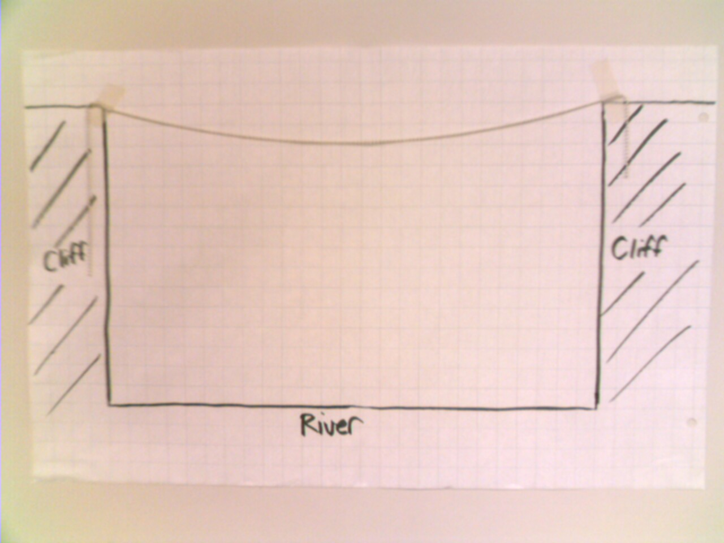
Make a scale model of the chasm and bridge: (15 minutes)
- In your group make a scale diagram of the side view of the chasm at Extreme Environment.
- Using masking tape put your scale diagram on a vertical surface in your classroom.
- Use the thin chain model the suspension bridge. If the slope at each end is steep, the bridge would be difficult to walk on to. Use masking tape to attach the chain to your chart paper.
- In your group, answer discussion question 1.

Collect coordinates to create a graphical model: (10 minutes)
- Draw a horizontal axis that connects the two end points of the bridge. Indicate the scale.
- In your group decide where to locate the vertical axis. Draw the vertical axis and indicate the scale.
- Record the coordinates of at least five points on the bridge. Be sure to include the end points and the low point on the bridge.
- Be sure that all members of the group have recorded the coordinates on their own sheets.
- In your group, answer discussion question 2.

From this point on you will be working individually. Please return the chain, markers and masking tape to your teacher.

4.15.3 Bridging the Gap: Day 1 (continued)
Name: _____________________________

Create a graphical model for your bridge: (10 minutes)

Record your data points. | Make a graphical model. Label the axes and indicate the scale.

Create two algebraic models for your bridge: (15 minutes)
- Using the data points you collected, create two algebraic models.

Name of Algebraic Model 1: | Name of Algebraic Model 2:
Work: | Work:
Algebraic Model 1: | Algebraic Model 2:

4.15.3 Bridging the Gap: Day 1 (continued)
Name: _____________________________

Discussion Questions: (10 minutes)

- What is the mathematical significance of the endpoints of the bridge and the low point of the bridge?

- What are two possible ways to create an algebraic model for the collected data?



Data Record for Bridging the Gap Day 1: Name: _______________________

Record your numerical model and algebraic models for the next class.

Algebraic Model 1:

Algebraic Model 2:

Teacher Feedback:

4.15.4 Bridging the Gap: Solutions (Teacher)
Day 1:

Form homogenous groups of 3 or 4 students. Students performing at levels 3 or 4 should be in groups of 3. Students performing at levels 1 and 2 could be in groups of 4.

Students will create a scale diagram on grid chart paper of the chasm dimensions. The picture below uses a scale of 1 square = 4 m.

Have the students model the suspension bridge with a chain. Home Depot sells lamp pull chain that is $0.60 per foot. Each group needs a 2 or 3 foot length. Ensure that the chain is not too steep at the end points since it would be difficult to climb onto or off the “bridge”. The chain forms a catenary which can be approximated by a quadratic function. For more information on catenaries see http://en.wikipedia.org/wiki/Catenary

Students will discuss in their groups the significance of the end points (zeros) and the low point (vertex).

The next two pictures show key points on the bridge and the location of the two axes.

4.15.4 Bridging the Gap: Solutions (Teacher) (continued)

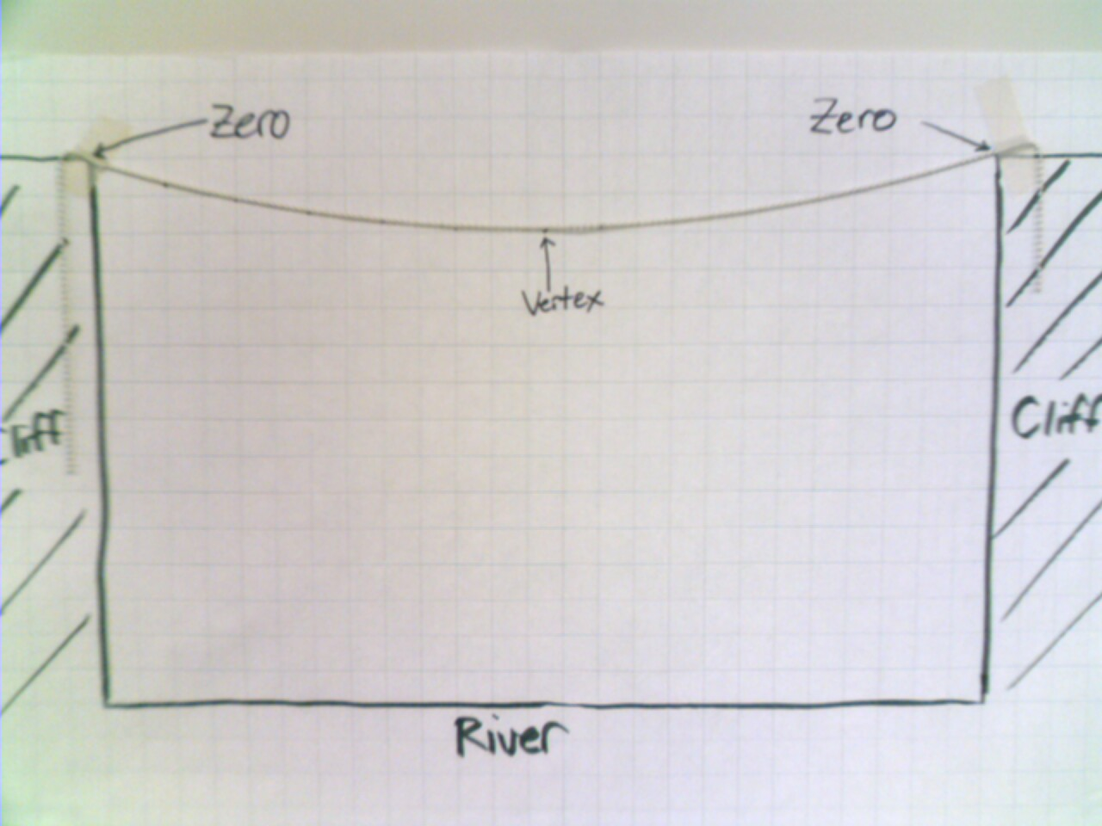

The x axis should connect the two end points of the bridge. The location of the y-axis can be determined by the student group. The solution provided places the vertex on the y-axis.

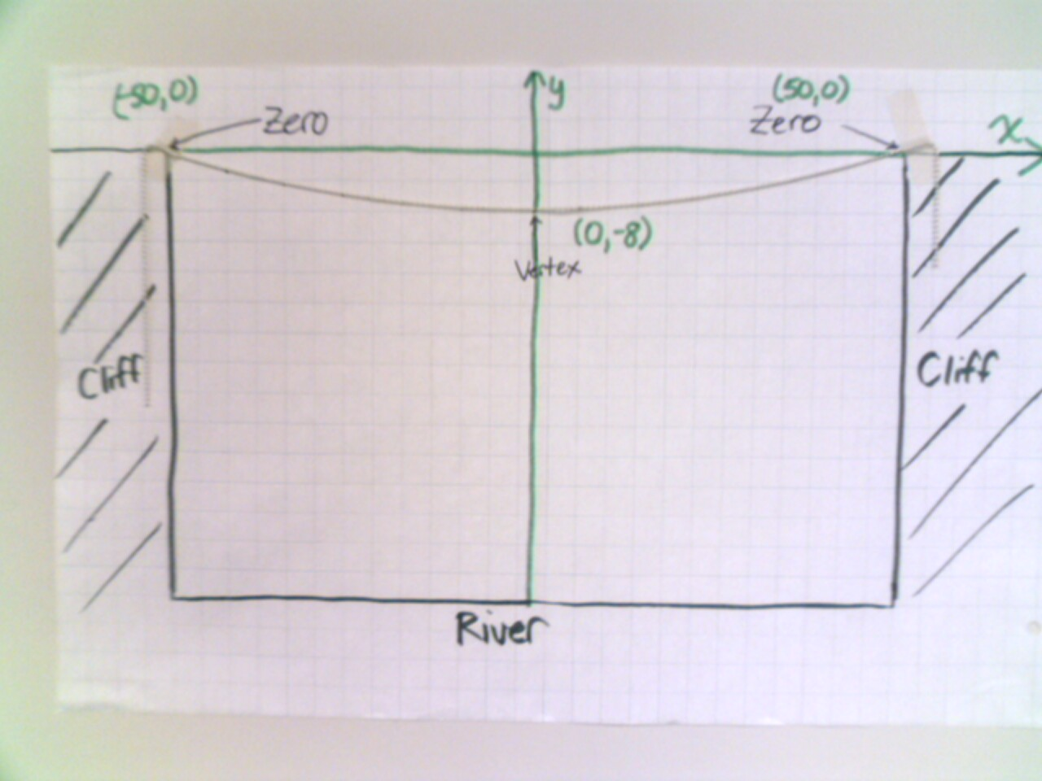

4.15.4 Bridging the Gap: Solutions (Teacher) (continued)

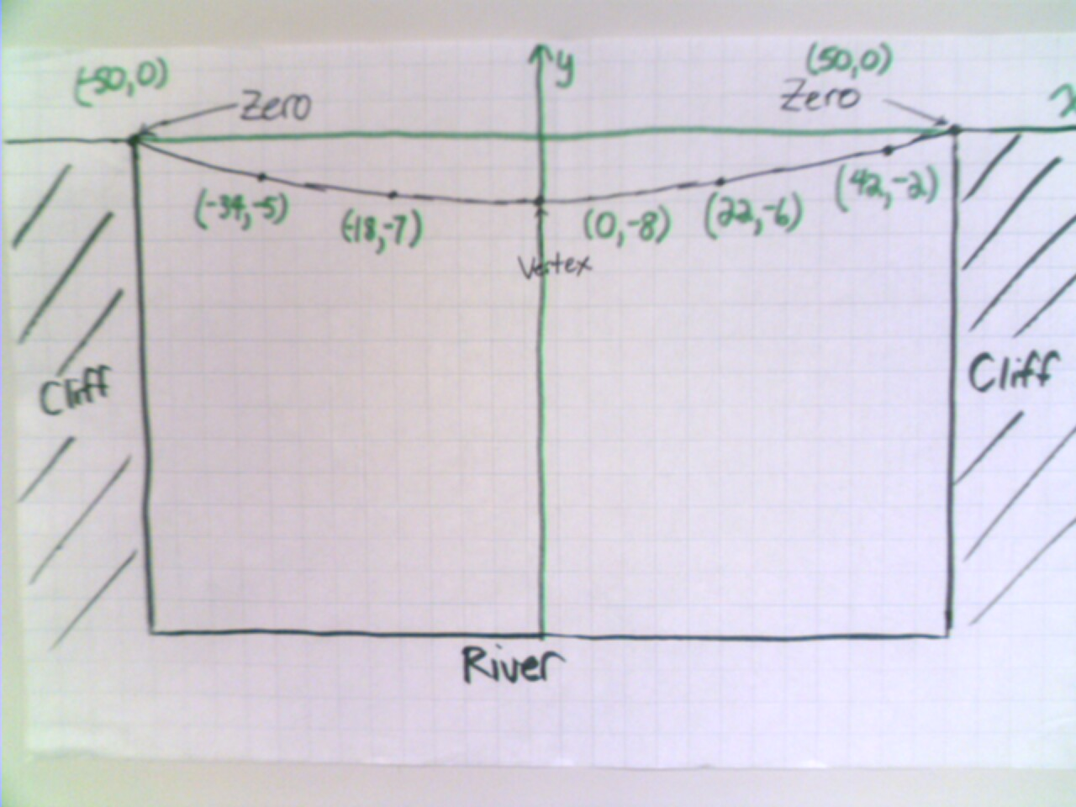

The students will determine at least five points including the vertex and both zeros. The students will discuss in their groups possible ways to find an algebraic model from this data (factored form or vertex form). The collected data should be shared with each member of the group as they will work individually from this point on.

Individually, the students will create a labelled graphical model, explain the significance of the end points and lowest point on the bridge and create two algebraic models.

Factored Form | Vertex Form
y = a(x – r)(x – s)  Roots are (-50,0) and (50,0) and (22,-6) is a point on the curve, then  -6 = a(22-(-50))(22+ 50)  -6 = a(72)(-28)  $$a = \frac{(−6)}{(\text{72})(−\text{28})}$$  a = 0.003  So, y = 0.003 (x + 50)(x – 50) is an algebraic model for the data. | y = a(x – h)² + k  The vertex is (0,-8) and (22,-6) is on the curve, then  -6 = a(22 – 0)² + (-8)  -6 = 484a – 8  $$a = \frac{2}{\text{484}}$$  a =0.004  So, y = 0.004x² – 8 is an algebraic model for the data.
Students submit the completed BLM 4.16.3. Teachers should assess student work and provide feedback.

Unit 4 : Day 16 : Bridging the Gap Midterm Summative Assessment |  |  |  | Grade 11 U/C
Minds On: 10 |  | Description/Assessment Goals  - Students will determine strengths and weaknesses in their algebraic models  - Students will test their algebraic models to see if they meet a design criterion.  - Students will determine a range of locations for a bungee jump station that meet certain criteria  - Expand and simplify quadratic expressions, solve quadratic expressions, and relate the roots of the quadratic equation to the corresponding graph (QFV.001)  - Demonstrate an understanding of functions, and make connections between the numeric, graphical, and algebraic representations of quadratic functions (QFV.002)  - Solve problems involving quadratic functions, including those arising from real-world applications. (QFV.003) |  | Materials  - BLM 4.16.1  - BLM 4.16.2  - Graphing calculators
Action: 60
Consolidate: 5
Total=75 min
Assessment
Opportunities
 | Minds On… | Whole Class → Discussion  Review the criteria and qualifiers used on the rubric (BLM 4.15.2)  Have students share how bungee jumping works by showing pictures or short video clips such as opening scene from James Bond movie Golden Eye.  Activate prior knowledge to ensure students understand the meaning of the maximum stretch for the bungee jump and understand domain and range.  Distribute student work from the previous class including BLM 4.15.1.  Return the last page of BLM 4.15.3 with teacher feedback. |  | History of Bungee Jumping:  http://www.extremesportscafe.com/bungie_overview.html  The physics of Bungee Jumping:  http://stokes.byu.edu/bungee.html  Teacher notes and a sample solution are contained in BLM 4.16.2
 | Action! | Individual→Analysis  Distribute BLM 4.16.1 and graphing calculators to students.  Students will test their algebraic model to see if it meets the maximum slope requirement.  Students will determine and justify the range of locations for the bungee jump station.
 | Consolidate Debrief | Whole Class → Collection of Material  Students will submit their completed work for evaluation using rubric  (BLM 4.15.2)
Extra Practice |  | Home Activity or Further Classroom Consolidation  Students can review for pencil and paper test on expectations not assessed by this task.  Teacher can assign practice questions as required.

4.16.1 Bridging the Gap: Day 2
Name: _____________________________
Materials:
- Numerical and algebraic models from previous class
- Graphing calculator
- Pencils and ruler

Method:
- Discuss the strengths and weaknesses of your algebraic models.
- State the domain and range for each of your models
- Determine whether your bridge model meets the maximum slope building code requirement. How would you make adjustments to your model if you needed to?
- Determine the range of locations for the bungee jump station that meet the safety code requirements.

Gather the necessary materials from your teacher. You will work individually for the entire class.

Discuss the strengths and weaknesses of your algebraic models: (15 minutes)
- Enter your data points from the last class into lists and create a scatter plot on the graphing calculator.
- Enter your factored form algebraic model as a function in the graphing calculator. Graph the function on the scatter plot.
- Analyze the strengths and weaknesses of your factored form algebraic model.
- Repeat the previous two steps for the vertex form algebraic model.

Factored Form | Vertex Form
Sketch of graph including axes   | Sketch of graph including axes
Strengths of Model: | Strengths of Model:
Weaknesses of Model: | Weaknesses of Model:

4.16.1 Bridging the Gap: Day 2 (continued)
Name: _____________________________

State the domain and range for each of your algebraic models: (10 minutes)

Factored Form | Vertex Form
Work: | Work:
Domain: | Domain:
Range: | Range:

Determine whether your bridge model meets the maximum slope building code requirement: (10 minutes).
- Calculate the slope of a segment from one of the two end points of the bridge to a point that is 5 m horizontally from the end of the bridge.
- Determine with justification whether the bridge meets the range of slopes in the building code requirement.

Slope = $\frac{\text{rise}}{\text{run}}$ or Slope = $\frac{y_{2} −y_{1}}{x_{2} −x_{1}}$ or Slope = $\frac{Δy}{Δx}$

Slope calculation:

Does the bridge meet the maximum slope requirement?

If your bridge failed to meet the requirement, what actions would correct the problem?

4.16.1 Bridging the Gap: Day 2 (continued)
Name: _____________________________

Investigate possible locations for the bungee jump station: (25 minutes)

Make a side view labelled sketch of the chasm including your bridge. Based on the safety codes, shade the three areas where no part of the bungee jump can occur.

Using the vertex form, determine the minimum distance from the bridge to the river. Use this result to calculate the stretched length of the bungee cord.

Show that by locating the bungee jump station 5 m from either end of the bridge the stretched length of the bungee jump cord is more than 10 m above the river.

4.16.1 Bridging the Gap: Day 2 (continued)
Name: _____________________________

Justify why the bungee jump station cannot be located at the lowest point of the bridge. (Use the vertex form of your algebraic model.)

Find the horizontal position for the bungee jump station so that the stretched bungee cord is exactly 10m above the river.

Based on the previous calculations, what range of horizontal positions can the bungee jump station be located to meet the safety requirements?

Submit your completed solutions to your teacher.

4.16.2 Bridging the Gap: Solutions (Teacher)

Day 2:

Students will work individually for the entire class. Distribute BLM 4.16.1 and the assessed graphical and mathematical models from the previous day. Students who were unsuccessful in determining a correct algebraic model could be provided with models to enable them to engage in the second day.

Distribute graphing calculators and have the students enter their data into lists and create a scatter plot.
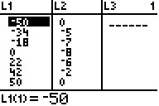
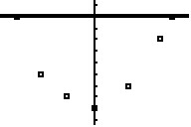

Have the students enter their algebraic models into the graphing calculator and reflect and reason on the appropriateness of their algebraic models.
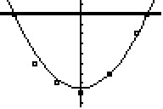

For the factored form model we see that the model accurately predicts the zeros but doesn’t accurately predict the vertex

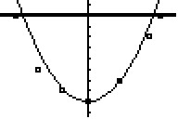

For the vertex form model we see that the model doesn’t accurately predict the zeros bit does accurately predict the vertex.

If the students perform a quadratic regression we see that the algebraic model shown compromises the two issues of zeros and vertex.
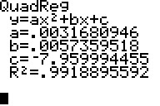
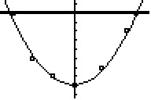

4.16.2 Bridging the Gap: Solutions (Teacher) (continued)

Students provide the domain and range for the each of the two algebraic models.

Factored Form | Vertex Form
Domain: $\left\{x∈R, −\text{50}≤x≤\text{50}\right\}$  Vertex: y = 0.003(0 – 50)(0 + 50)  y = 0.003 (-50)(50)  y = -7.5  Range: $\left\{y∈R, y≥−7\text{.}5\right\}$ | Zeroes: 0 = 0.004 x² - 8  0.004x² = 8  $x^{2} = \frac{8}{0\text{.}\text{004}}$  x² = 2000  $x = ±\text{44}\text{.}7$  Domain: $\left\{x∈R, −\text{44}\text{.}7≤x≤\text{44}\text{.}7\right\}$  Range: $\left\{y∈R, y≥−8\right\}$

Students determine if their bridge model meets the criteria for maximum slope. Students should use the factored form model since more accurately predicts the zeros.

End of Bridge Slope
Find the coordinates of a point 5m horizontally from the end of the bridge. (ie x=45 or x=-45)  For x=45,  y = 0.003(45 – 50)(45 + 50)  y = 0.003(-5)(95)  y = -1.43 | Slope of segment from (50,0) to (45,-1.43)  $$m = \frac{0−(−1\text{.}\text{43})}{\text{50}−\text{45}} =\frac{1\text{.}\text{43}}{5}$$  m = 0.285  This slope does not fall with the range 0.1 to 0.25.

Students should offer ways to make their bridge meet this building requirement such as shortening the length of the bridge to decrease the slope but this will raise the vertex as well.

Students will determine the minimum distance to the river using the vertex (i.e. 60 – 8 = 52 m). Using this distance they calculate the stretch length of the bungee cord (i.e. 90% of 52 = 46.8 m).

Next, using the factored form, calculate the distance from the bridge to the water for a point that is 5m horizontally from the end of the bridge.

Find the coordinates of the point on the bridge: (Use x= -45or x= 50)
y = 0.003(x – 50)(x + 50)
y = 0.003(-45 – 50)(-45 + 50)
y = 0.003(-95)(5)
y = -1.43

So, the point has coordinates (-45,-1.43)
Thus, the distance from the bridge to the river is 60 – 1.43 = 58.57 m
The difference between the distance and the stretch length is 58.57 - 46.8 = 11.77 m
Since this exceeds the minimum distance from the river, it is safe to locate the bungee jump station 5 m horizontally from either end of bridge.

4.16.2 Bridging the Gap: Solutions (Teacher) (continued)

Students justify why the vertex is not a safe location for the bungee jump station.

The coordinates of the vertex are (0,-8)

The distance to the river is 60 – 8 = 52m

The difference between the distance and the stretch length is 52 - 46.8 = 5.2 m
Since this is less than the minimum distance from the river of 10 m, it is unsafe to locate the bungee jump station at the lowest point of the bridge.

Students determine the horizontal distance that has the difference between the vertical distance from the bridge to the river and the stretch length of the bungee chord is exactly 10m.

The factored form should be used as it better models the bridge near the zeros. Expanding the factored form algebraic model we get:
y = 0.003(x – 50)(x + 50)
y = 0.003(x² – 2500)
y = 0.003x² – 7.5

When the difference is 10 m we have:
Distance to river – 46.8 = 10
Distance to river = 56.8

So, the coordinates of the point on the bridge are (x, 56.8 - 60) = (x, -3.2)

Solve: -3.2 = 0.003x² – 7.5
4.3 = 0.003x²
$x^{2} = \frac{4\text{.}3}{0\text{.}\text{003}}$
$x = ±\text{37}\text{.}\text{86}$

So, relative to the end points of the bridge points that are 12.14m measured horizontally have the difference between the distance to the water and the stretch length is exactly 10 m.

Finally, students determine the range of horizontal distances that are safe locations for the bungee jump station.

The domain for horizontal distances for safe locations of the bungee jump station are:

$\left\{x∈R, −\text{45}≤x≤−\text{37}\text{.}\text{86} \text{or} \text{37}\text{.}\text{86}≤x≤\text{45}\right\}$
Note: Students could provide a description, a number line or, an inequality statement.

Students hand in BLM 4.16.1. Evaluate student work from both days using rubric (BLM 4.15.2).

Midterm Summative Performance Task #2
Unit 4 : Day 15 : Leaky Tower Midterm Summative Assessment |  |  |  | Grade 11 U/C
Minds On: 10 min |  |  | Description/Assessment Goals  - Demonstrate an understanding of functions, and make connections between the numeric, graphical, and algebraic representations of quadratic functions (QFV.002)  - Solve problems involving quadratic functions, including those arising from real-world applications. (QFV.003) | Materials  - BLM 4.15.1 – BLM 4.15.6  - transparent containers (one/group) (eg. 1 L water bottles)  - basins/waste bins  - paper towels  - masking tape  - stop watches  - markers  - rulers
Action: 60 min
Consolidate: 5 min
Total= 75 min
Assessment
Opportunities
 | Minds On… | Previous Day: Whole Class → Demonstration  Demonstrate the leaking of water from a hole on the side of a container. Continue the demonstration by allowing water to drain from the bottom hole. Ask students to reflect on the possible graph(s) to model the relationship of height of the water vs. time.  Distribute BLM 4.15.1 for homework.  Small Groups → Discussion  Share responses to anticipation guide (BLM 4.15.1) completed the night before for homework.  Whole Class → Discussion  Distribute BLM 4.15.2 and familiarize students with procedure of the experiment. Distribute evaluation rubric (BLM 4.15.4) and discuss expectations for different levels. |  |  |  | Refer to http://www.eureka4you.com/wtower-on-g/index.htm for pictures of water towers in Ontario communities.  Refer to BLM 4.16.5 for equipment.  Homogeneous grouping should be used for the activity.  Each group will need a container with a hole approximately 3 mm in diameter made at the bottom and another hole at the side. The holes on the side should be made at integral heights (i.e. 1 cm, 2 cm, etc…) Groups can have different containers and different side hole heights. Water level does not need to be at the top.  Learning skills (teamwork) can be evaluated using a checkbric.  BLM 4.15.3 can be evaluated before day 2.
 | Action! | Small Groups → Exploration  Students will run the experiment and then answer group discussion questions at the bottom of BLM 4.15.2. Remind students to place tape 0.5 cm from the bottom of the container. This will account for the fact that many containers do not have a completely flat bottom. Groups should be given at most 30 minutes to complete exploration.  Individual → Modelling  Distribute BLM 4.15.3. Students should be given 30 minutes to complete it.
 | Consolidate Debrief | Small Groups → Collection of Materials  Clean up and collection of materials.
Concept Practice  Skill Drill |  | Home Activity or Further Classroom Consolidation  Students will complete selection of exercises for review and practice of paper/pencil assessment on Day 3. |  |  |  | This summative should be followed by a paper/pencil assessment evaluating skills in knowledge.

4.15.1 Leaky Tower: Anticipation Guide

Name: ________________________
Instructions:
- Check “Agree” or “Disagree” beside each statement below.
- You will have a chance to revisit your choices at the end of the experiment. You will compare the choices that you make now with the choices that you will make after.

Before |  | Statement | After
Agree | Disagree | Statement | Agree | Disagree
 |  | - The water will drain at a constant rate.
 |  | - A hole at the bottom of the container will take longer to drain than a hole at the side of the container.
 |  | - The rate of flow depends on the size of the container/size of hole.
 |  | - The amount of liquid in the container will not affect the rate of flow/the shape of the data.

Hypothesis
Sketch a graph showing your predicted relationship between the depth of the water and time. Note: The water will drain out of a hole in the side while the hole in the bottom is plugged. Then the hole in the bottom will be unplugged and the water will continue draining out. Indicate the point where the water level will reach the hole on the side.

Time
Depth
4.15.2 Leaky Tower Name: ________________________
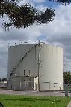
Many communities across the province use water towers as a part of the water delivery infrastructure. The purpose of a water tower is three fold: to act as a reservoir; a pressure release; and as a pressure regulator. What would happen if the water tower developed a leak? How long would it take to drain? Would the water leak out at a constant rate?

Day 1:
Your group will be collecting data as water flows out of two holes made in a container.
http://www.eureka4you.com/../wtower-on-h/hamilton3.htm

Preparation:
- In your group of three, assign the following roles to each group member: timer, recorder, engineer.
- Collect your equipment: three containers (the water tower model, water container and a container to collect the water), stopwatch, masking tape, ruler.
0
1
2
3
4
5
6
7
8
-3
-2
-1
-4
Procedure (10 minutes):
- On a piece of masking tape (as long as the cylindrical part of the container) place markings at 0.5 cm intervals. (Do not number the tape at this time.)
- Place the tape vertically on your water tower model, starting 0.5 cm from the bottom.
- Number the tape with zero being located at the side and positive numbers above the hole and negative numbers below the hole (see example at right).
- Plug the hole in the bottom and the side with masking tape.
- Position your collection container to catch the water as it leaks from the water tower model.
- Fill your water tower model to an integral value well above the hole.

Data collection (15 minutes):
- Pull the tape on the side of the container and record the depth at 10 second intervals until it stops flowing. The timer should call out “time” to indicate 10 seconds have passed, the engineer will then read the depth and the recorder will record the data until the water level reaches the hole.
- Remove the tape on the bottom of the container and continue recording the depth at 10 second intervals until it stops flowing.
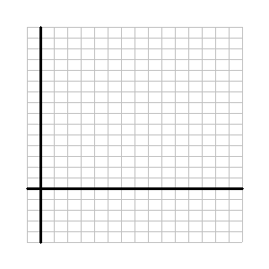
- Each group member should record the data for their own analysis.

Group Discussion Questions (5 minutes):
- Create a scatter plot for the data. Label your axes.
- Graphically model the data using quadratic functions.
- Identify the graphical model(s) that best fits the data.
- Identify key points on the graph and their relevance to the experiment.
- Discuss possible algebraic models that could be used to analyse the data.
- How well did your anticipated graphs match the actual data?
4.15.3 Leaky Tower

Name: ________________________

Day 1: Independent Analysis

- Determine two algebraic models for the data that represents the depth of the water above the hole.
Vertex Form | Standard/Expanded Form

- Determine two algebraic models for the data that represents the depth of the water below the hole.
Vertex Form | Standard/Expanded Form

4.15.3 Leaky Tower (continued)

Name: ________________________

- Fill in the chart.
Statement | Before |  | After |  | Briefly justify your reasoning reflecting on your initial choices and the results of the experiment
 | Agree | Disagree | Agree | Disagree
The water will drain at a constant rate.
A hole at the bottom of the container will take longer to drain than a hole at the side of the container.

THINKING
Reasoning and Proving
Criteria |  | Level 1 |  | Level 2 |  | Level 3 | Level 4
Degree of clarity in explanations and justifications  #3, #4, #5, #11 |  | Justifies in a way that is partially understandable |  | Justifies so that the teacher understands, but would likely be unclear to others |  | Justifies clearly for a range of audiences | Justifies particularly clearly and with detail
Making comparisons,  conclusions and justifications connected to the data  , #4, #5, #10, #11 |  | Justifies with a limited connection to the model presented |  | Justifies with some connection to the model presented |  | Justifies with a direct connection to the model presented | Justifies with a direct connection to the model presented, with evidence of reflection
Exploring and Reflecting
Reflecting on reasonableness of original hypothesis and revising if needed #3 | Reflects and revises inappropriately to the  situations |  | Reflects and revises appropriately to include some situations |  | Reflects and revises appropriately to include most significant situations |  | Reflects and revises appropriately to include all situations
APPLICATION
Selecting Tools and Computational Strategies
Select and use appropriate tools and strategies to model the data, or solve a problem  #1, #2, #7, #8 | Selects and applies with major errors, omissions, or mis-sequencing |  | Selects and applies with minor errors, omissions or mis-sequencing |  | Selects and applies accurately, and logically sequenced |  | Selects and applies accurately and logically sequenced, using the most appropriate tools
Connecting
Makes connections among graphical model and context  #6 |  | Makes limited connections |  | Makes some connections |  | Makes most connections | Makes all possible connections
Relate mathematical ideas to situations drawn from other contexts #11 |  | Makes weak connections |  | Makes simple connections |  | Makes appropriate connections | Makes strong connections
COMMUNICATION
Representing
Creation of algebraic models to represent the data  #1, #2, #6 |  | Creates a model that represents little of the range of data |  | Creates a model that represents some of the range of data |  | Creates a model that represents most of the range of data | Creates a model that represents the full range of data
Communicating #1-11
Criteria |  | Level 1 |  | Level 2 |  | Level 3 | Level 4
Ability to read and interpret mathematical language, charts, and graphs |  | Misinterprets a major part of the information, but carries on to make some otherwise reasonable statements |  | Misinterprets part of the information, but carries on to make some otherwise reasonable statements |  | Correctly interprets the information, and makes reasonable statements | Correctly interprets the information, and makes subtle or insightful statements
Correct use of mathematical symbols, labels, units and conventions |  | Sometimes uses mathematical symbols, labels and conventions correctly |  | Usually uses mathematical symbols, labels and conventions correctly |  | Consistently uses mathematical symbols, labels and conventions correctly | Consistently and meticulously uses mathematical symbols, labels and conventions
Appropriate use of mathematical vocabulary |  | Sometimes uses mathematical vocabulary correctly when expected |  | Usually uses mathematical vocabulary correctly when expected |  | Consistently uses mathematical vocabulary correctly when expected | Consistently uses mathematical vocabulary correctly, with novel uses
Appropriate use of mathematical vocabulary |  | Sometimes uses mathematical vocabulary correctly when expected |  | Usually uses mathematical vocabulary correctly when expected |  | Consistently uses mathematical vocabulary correctly when expected | Consistently uses mathematical vocabulary correctly, with novel uses
4.15.4 Task Rubric for Midterm Summative Assessment: The Leaky Tower
4.15.5 Leaky Tower: Guide (Teacher)

Teacher Guide

Equipment:

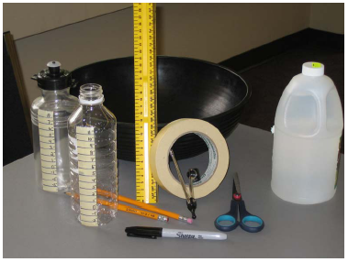

Placement and numbering of tape:

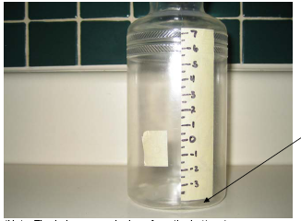
Note: Tape placed 0.5 cm from bottom.

(Note: The hole was made 4 cm from the bottom.)
4.15.5 Leaky Tower: Guide (continued)

Water draining from the side hole:

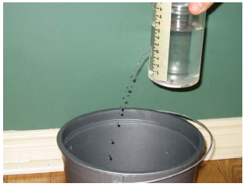

Water draining from the bottom hole:

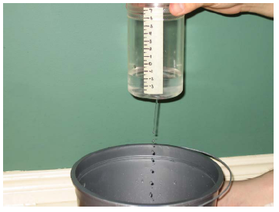

4.15.6 Leaky Tower: Solutions (Teacher)

Sample Solution

Data:

Time  (sec) | 0 | 10 | 20 | 30 | 40 | 50 | 60 | 70 | 80 | 90 | 100 | 110 | 120 | 130 | 140 | 150 | 160 | 170 | 180 | 190
Depth  (cm) | 8 | 7.1 | 6.2 | 5.3 | 4.4 | 3.6 | 2.9 | 2.3 | 1.7 | 1.3 | 0.9 | 0.5 | 0.2 | 0.05 | 0 | -1 | -2 | -2.6 | -3.1 | -3.5
(Note: This data can be used for students who were absent from Day 1 or for groups who did not obtain “good” data.)

Scatter Plot:
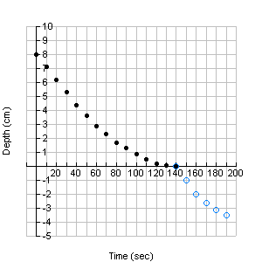

Day 1: Independent Analysis

- Determine two algebraic models for the data that represents the depth of the water above the hole.
Vertex Form | Standard/Expanded Form
Let d be the depth and t be the time:  Vertex is (140, 0), therefore equation is:  $d\left(t\right)=a{\left(t−\text{140}\right)}^{2}$.  Find “a”: substitute vertical intercept, (0, 8):  $$\begin{aligned}8=a{\left(0−\text{140}\right)}^{2} \\ 8=a{\left(−\text{140}\right)}^{2} \\ 8=\text{19600}a \\ a=0\text{.}\text{000408}\end{aligned}$$  Algebraic model:  $$d\left(t\right)=0\text{.}\text{000408}{\left(t−\text{140}\right)}^{2}$$ | Use the vertex form and expand:  $$\begin{aligned}d\left(t\right)=0\text{.}\text{000408}{\left(t−\text{140}\right)}^{2} \\ 0\text{.}\text{000408}(t^{2}−\text{280}t+\text{19600}) \\ 0\text{.}\text{000408}t^{2}−0\text{.}\text{11424}t+7\text{.}\text{9968}\end{aligned}$$

4.15.6 Leaky Tower: Solutions (continued)

- Determine two algebraic models for the data that represents the depth of the water below the hole.
Vertex Form | Standard/Expanded Form
Vertex is (190, -3.5), therefore equation is:  $d\left(t\right)=a{\left(t−\text{190}\right)}^{2}−3\text{.}5$.  Find “a”: substitute zero, (140, 0):  $$\begin{aligned}0=a{\left(\text{140}−\text{190}\right)}^{2}−3\text{.}5 \\ 3\text{.}5=a{\left(−\text{50}\right)}^{2} \\ 3\text{.}5=\text{2500}a \\ a=0\text{.}\text{0014}\end{aligned}$$  Algebraic model:  $$d\left(t\right)=0\text{.}\text{0014}{\left(t−\text{190}\right)}^{2}−3\text{.}5$$ | Expand either the vertex form or factored form.  $$\begin{aligned}d\left(t\right)=0\text{.}\text{0014}{\left(t−\text{190}\right)}^{2}−3\text{.}5 \\ 0\text{.}\text{0014}\left(t^{2}−\text{380}t+\text{36100}\right)−3\text{.}5 \\ 0\text{.}\text{0014}t^{2}−0\text{.}\text{532}t+\text{50}\text{.}\text{54}−3\text{.}5 \\ 0\text{.}\text{0014}t^{2}−0\text{.}\text{532}t+\text{47}\text{.}\text{04}\end{aligned}$$

- Fill in the chart.
Statement | Before |  | After |  | Briefly justify your reasoning reflecting on your initial choices and the results of the experiment
 | Agree | Disagree | Agree | Disagree
The water will drain at a constant rate. |  |  |  |  | I disagreed with this statement because the water very quickly at the start but then slowed down as time went on. This was apparent in the graphs in that the data created a curve rather than a straight line.
A hole at the bottom of the container will take longer to drain than a hole at the side of the container. |  |  |  |  | I disagreed after the experiment because the rate for the water draining from the hole on the bottom was quicker than the hole on the side. This was apparent from the steepness of the graphs. The data for the hole on the bottom fell at a steeper rate than the hole on the side.

Unit 4 : Day 16 : Leaky Tower Midterm Summative Assessment |  |  |  | Grade 11 U/C
Minds On: 5 min |  |  | Description/Assessment Goals  - Expand and simplify quadratic expressions, solve quadratic expressions, and relate the roots of the quadratic equation to the corresponding graph (QFV.001)  - Demonstrate an understanding of functions, and make connections between the numeric, graphical, and algebraic representations of quadratic functions (QFV.002)  - Solve problems involving quadratic functions, including those arising from real-world applications. (QFV.003) | Materials  - BLM 4.16.1 – BLM 4.16.2  - Graphing calculator
Action: 60 min
Consolidate: 10 min
Total= 75 min
Assessment
Opportunities
 | Minds On… | Whole Class → Discussion  Distribute assessed work from last class. Introduce and discuss objectives of the assessment. Refer to evaluation rubric (BLM 4.15.4) and discuss expectations for different levels.  Distribute graphing calculators and review necessary skills such as entering data into lists, graphing a function and changing window settings. |  |  |  | Any students who were absent from day 1 or who did not get “good” data can be given data set from BLM 4.15.6.
 | Action! | Individual → Analysis of Models  Distribute BLM 4.16.1. Students should be given 60 minutes to complete it.
 | Consolidate Debrief | Individual → Review  Students will review concepts to be covered on next day by paper/pencil assessment.
Concept Practice  Skill Drill |  | Home Activity or Further Classroom Consolidation  Students will complete selection of exercises for review to practice for paper/pencil assessment next day. |  |  |  | This summative should be followed by a paper/pencil assessment that will evaluate skills in the knowledge category.

4.16.1: Leaky Tower

Name: ________________________

Day 2: Independent Analysis

- Obtain a graphing calculator and enter your data into lists. Graph the standard form of the models you derived for the data above the hole and the data below the hole. Rate how well your algebraic models fit the data on a scale from 0 to 1 (1 being a perfect fit). Justify your reasoning.

- a) Discuss the similarities and differences between the algebraic models (compare the data above the hole and below the hole).

  - How are the similarities and differences apparent in the graphical models?

  - How do you account for the similarities and differences in the data obtained from the experiment?

4.16.1: Leaky Tower (continued)

- State the domain and range for the two algebraic models (above the hole and below the hole).
Above the hole | Below the hole

- Determine the depth of the water after 27 seconds.

- Using one of the forms of the algebraic model for the “above the hole” data, determine how long it took for the depth to reach the hole on the side.

- Using one of the forms of the algebraic model for the “below the hole” data, determine how long it took for the water to completely drain.

4.16.1: Leaky Tower (continued)

- If the model for the data below the hole was true for the entire container, what would be the distance from the bottom of the container to water level at the top of the container? Justify your reasoning.

- The scatter plot below shows the data collected by another group.
Identify the following and justify your answers.
A. The height of the water before the leak started.

B. The height of the hole on the side of the container.

C. The length of time it took to drain to the hole on the side.

D. The length of time it took to drain to the hole on the bottom.
4.16.2: Leaky Tower: Solutions (Teacher)

Day 2: Independent Analysis

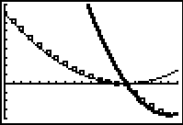
- Obtain a graphing calculator and enter your data into lists. Graph the standard form of the models you derived for the data above the hole and the data below the hole. Rate how well your algebraic models fit the data on a scale from 0 to 1 (1 being a perfect fit). Justify your reasoning.

I’d rate my model at 0.9. The model for the data above the side hole sits just below the data points. The model for the data below the side hole also sits just below the data points.

- a) Discuss the similarities and differences between the algebraic models (compare the data above the hole and below the hole).

- Both models have positive “a” values but the values are different.
- Both have positive “c” values or vertical intercepts but they occur at different points.
- The vertex for each parabola occurs at different points.

  - How are the similarities and differences apparent in the graphical models?

- The different “a” values are apparent in that the parabolas have different widths. The parabola for the above the hole data is wider than the parabola for the below the hole data. The parabola for the below the hole data is steeper at the start than the parabola for the above the hole data.
- The vertical intercept for the above the hole parabola is lower than the below the hole parabola.
- The vertex for the above the hole parabola sits on the horizontal axis. The vertex for the below whole parabola is below the horizontal axis.

  - How do you account for the similarities and differences in the data obtained from the experiment?

- The different values of “a” are due to the fact that the water drained out of the side hole at a slower rate than the hole in the bottom.
- This difference in rate also explains the different vertical intercept. The quicker rate for the below the hole data makes its intercept occur at a higher point on the vertical axis.
- The difference in the vertex comes from the numbering used on the masking tape and the different times it took for the water to drain to each hole. The water took longer to reach the hole on the bottom.

4.16.2: Leaky Tower: Solutions (continued)

- State the domain and range for the two algebraic models (above the hole and below the hole).
Above the hole | Below the hole
Domain: $\left\{t∈ℜ,0≤t≤\text{140}\right\}$  Range: $\left\{d∈ℜ,0≤d≤8\right\}$ | Domain: $\left\{t∈ℜ,\text{140}≤t≤\text{190}\right\}$  Range: $\left\{d∈ℜ,−3\text{.}5≤d≤0\right\}$
Note: Domain and range can be given in a number line, description or inequality statement

- Determine the depth of the water after 27 seconds.
Substitute t = 27 into $d=0\text{.}\text{000408}{\left(t−\text{140}\right)}^{2}$.
$$\begin{aligned}d=0\text{.}\text{000408}{\left(\text{27}−\text{140}\right)}^{2} \\ 0\text{.}\text{000408}{\left(−\text{113}\right)}^{2} \\ 5\text{.}2\text{cm}\end{aligned}$$

- Using one of the forms of the algebraic model for the “above the hole” data, determine how long it took for the depth to reach the hole on the side.
Using vertex form, let d = 0:  $$\begin{aligned}0=0\text{.}\text{000408}{\left(t−\text{140}\right)}^{2} \\ 0={\left(t−\text{140}\right)}^{2} \\ 0=t−\text{140} \\ t=\text{140}\end{aligned}$$ | Using expanded form, let d = 0:  $$0=0\text{.}\text{000408}t^{2}−0\text{.}\text{11424}t+7\text{.}\text{9968}$$  Use quadratic formula:  $$\begin{aligned}t=\frac{0\text{.}\text{11424}±\sqrt{{\left(0\text{.}\text{11424}\right)}^{2}−4\left(0\text{.}\text{000408}\right)\left(7\text{.}\text{9968}\right)}}{2\left(0\text{.}\text{000408}\right)} \\ \frac{0\text{.}\text{11424}}{0\text{.}\text{000816}} \\ \text{140}\end{aligned}$$

- Using one of the forms of the algebraic model for the “below the hole” data, determine how long it took for the water to completely drain.
Vertex Form | Standard/Expanded Form
Using vertex form, let d = 0:  $$\begin{aligned}0=0\text{.}\text{0014}{\left(t−\text{190}\right)}^{2}−3\text{.}5 \\ 3\text{.}5=0\text{.}\text{0014}{\left(t−\text{190}\right)}^{2} \\ \text{2500}={\left(t−\text{190}\right)}^{2} \\ ±\text{50}=\left(t−\text{190}\right) \\ t=\text{140} \text{or} t=\text{240}\end{aligned}$$  t = 140 since t = 240 is not in domain. | Using standard/expanded form, let d = 0:  $$0=0\text{.}\text{0014}t^{2}−0\text{.}\text{532}t+\text{47}\text{.}\text{04}$$  $$\begin{aligned}t=\frac{0\text{.}\text{532}±\sqrt{{\left(0\text{.}\text{532}\right)}^{2}−4\left(0\text{.}\text{0014}\right)\left(\text{47}\text{.}\text{04}\right)}}{2\left(0\text{.}\text{0014}\right)} \\ \frac{0\text{.}\text{532}±\sqrt{0\text{.}\text{0196}}}{0\text{.}\text{0028}} \\ \frac{0\text{.}\text{532}±0\text{.}\text{14}}{0\text{.}\text{0028}} \\ t=\text{240} \text{or} t=\text{140}\end{aligned}$$  t = 140 since t = 240 is not in domain.

4.16.2: Leaky Tower: Solutions (continued)

- If the model for the data below the hole was true for the entire container, what would be the distance from the bottom of the container to the water level at the top of the container? Justify your reasoning.

The distance from the bottom of the container to the water level would be about 51 cm. If you look at the expanded form of the algebraic model ($d=0\text{.}\text{0014}t^{2}−0\text{.}\text{532}t+\text{47}\text{.}\text{04}$), the value of “c” tells us the vertical intercept which is 47.04 cm. We have to remember that the zero mark was 4 cm above the bottom of the container so we need to add 4 cm. Adding 47.04 and 4, we get 51.04 cm.

- The scatter plot below shows the data collected by another group.
Identify the following and justify your answers.
A. The height of the water before the leak started.

The vertical intercept (13.8) added with the smallest y-value (-6.1) gives the height of water to be 19.9 cm.

B. The height of the hole on the side of the container.

The height of the hole was about 6 cm above the bottom of the container. This is the distance from 0 to the smallest y-value (-6.1).

C. The length of time it took to drain to the hole on the side.

The x-intercept is the length of time it took to drain to the hole on the side which is 170 seconds.

D. The length of time it took to drain to the hole on the bottom.

This is the x-coordinate of the lowest point which is 220 seconds.

